The Peterloo Massacre

Study the three sources and then answer the questions which follow

Source A: From the Manchester Chronicle, 21 August 1819. This newspaper was on the side of the government.

When Mr Hunt arrived the crowd clapped loudly. Soon there was confusion. There was a crush and people cried out and shouted. An army officer was hit on the forehead with a brick. The soldiers were not to blame for all the deaths. No one thought that people would bring weapons to the meeting, but they did. Many people had their pockets full of stones.

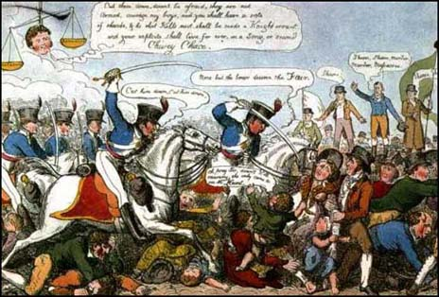
Oh pray sir, don’t kill mummy, she only came to see Mr Hunt
Shame, shame, murder, murder.
Cut them down, don’t be afraid, they are not armed, courage my boys, and you shall have a vote of thanks, and he that kills most shall be made a knight errant, and your exploits shall live for ever in a song.

Source B: a cartoon about Peterloo, September 1819
I saw no one lift up sticks to the soldiers. If any stones had been thrown I would have seen it. I am over six feet high and I was able to see everything that happened. I heard no swearing and no violence from the crowd.

Mr Hunt had just started his speech when the soldiers charged into the crowd forcing them to the ground and crushing the people.

Source B: John Smith, a journalist, who was at Peterloo. Smith worked for the Liverpool Mercury which was in favour of working people getting the vote.

Source C: John smith, a journalist, who was at Peterloo. Smith worked for the Liverpool Mercury which was in favour of working people getting the vote.

Questions
- Who does source A blame for the deaths? Give reasons
- Who does sources C blame for the deaths? Give reasons?
- How does source B support source C?
- How are the soldiers portrayed in source B?
- Can you trust source B. Explain your answer. (Remember to think of whether the event can be proved, opinion, bias).
- Newspapers gave different sides of the event. Why did the government want to stop newspapers printing reports about Peterloo?

