The Captain Swing Movement: Source evaluation
The following sources are all concerned with the Captain Swing Movement which occurred in the early nineteenth century. Study the sources and answer the questions which follow.
Source 1: A poem by Peter Higginbotham entitled the Ballad of Captain Swing
In eighteen hundred and twenty nine
The summer was wet and the sun would not shine,
The terrible harvest was surely a sign -
An omen for Captain Swing.

Chorus:
Oh Captain Swing, he'll come in the night,
To set all your buildings and crops alight,
And smash your machines with all his might,
That dastardly Captain Swing!

The following year was just as bad
No corn to be reaped and no work to be had.
Poor labouring men were driven quite mad
And rallied to Captain Swing.

They cried to the farmers to take heed,
These threshing machines are the last thing we need,
If you must persist in doing this deed.
You'll soon hear from Captain Swing

And all through the heart of this fair land,
The call went abroad for justice to stand.
Men rose up and marched to make their demand
In the name of Captain Swing.

From Norfolk to Berkshire went the cry,
For food in our bellies we'll gladly die.
Machines were smashed up and fires lit the sky,
As promised by Captain Swing.

As poor men assembled and attacked,
The justices read out the Riot Act.
T'was soon clear the odds were heavily stacked
Contrary to Captain Swing.

The leaders were charged and guilty found,
Some were deported and some scaffold bound,
But true working men forever should sound
The praises of Captain Swing

Source 2: A map showing areas of Captain Swing action.

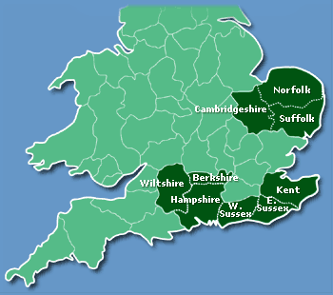

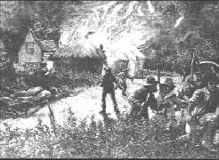
Source 3: a nineteenth century engraving of a hayrick fire

Questions

- What do the sources tell you about the Captain Swing movement?
- How do sources 1 and 2 agree?
- What part of source 1 supports source 3?
- Source 1 is a poem – a creative description of the event. Do you think this is reliable evidence? Explain.
- Which source is the most useful if following an enquiry on the Captain Swing movement?
- What other evidence would help you discover more about Captain Swing?

