GCSE controlled assessment: Whitechapel at the time of the Ripper murders

Sources

Source B

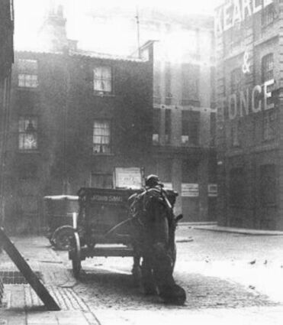
Photograph of Mitre Square, end of nineteenth century

Source C

“Turn down this side street out of the main Whitechapel Road. It may be well to tuck out of view any bit of jewellery that may be glittering about… The street is oppressively dark, though at present the gloom is relieved somewhat by feebly lighted shopfronts. Men are lounging at the doors of the shops, smoking evil-smelling pipes. Now round the corner into another still gloomier passage, for there are no shops here to speak of. This is the notorious Wentworth Street. The police used to make a point of going through this only in couples, and possibly may do so still when they go there at all. It is getting on into the night, but gutters, and doorways, and passages, and staircases appear to be teeming with children. Listen for a moment at this next house. There is a scuffle going on upon the staircase - all in the densest darkness - and before you have passed a dozen yards there is a rush down-stairs and an outsurging into the street with fighting and screaming… it makes you shudder as you look at those curly-headed sharp-witted children who leave their play to gather around the mêlée. God help the little mortals! How can they become anything but savages, “pests of society,” the “dangerous classes,” and so on? How black and unutterably gloomy all the houses look!”

An Autumn Evening in Whitechapel
3 November 1888, Littell's Living Age, (a magazine)

Source D
Sir,
In reply to your letter I enclose a report of the circumstances of the Mitre Square Murder and I now give an account regarding the erasing of the writing on the wall in Goulston Street …
On the 30th September I arrived at Leman Street Station shortly before 5 A.M. and ascertained from the Superintendant Arnold all that was known there relative to the two murders. The most pressing question at that moment was some writing on the wall in Goulston Street evidently written with the intention of inflaming the public mind against the Jews, and which Mr. Arnold, with a view to prevent serious disorder, proposed to obliterate, and had sent down an Inspector with a sponge for that purpose, telling him to await his arrival.
I considered it desirable that I should decide the matter myself, as it was one involving so great a responsibility whether any action was taken or not. I accordingly went down to Goulston Street at once … it was just getting light, the public would be in the streets in a few minutes, in a neighbourhood very much crowded on Sunday mornings by.
The writing was on the jamb of the open archway or doorway visible in the street and could not be covered up without danger of the covering being torn off at once.
A discussion took place whether the writing could be left covered up or whether any portion of it could be left for an hour until it could be photographed; but after taking into consideration the excited state of the population in London generally at the time, the strong feeling which had been excited against the Jews, and the fact that in a short time there would be a large concourse of the people in the streets…I considered it desirable to obliterate the writing at once, having taken a copy of which I enclose a duplicate.
I do not hesitate myself to say that if that writing had been left there would have been an onslaught upon the Jews, property would have been wrecked, and lives would probably have been lost; and I was much gratified with the prompitude with which Superintendent Arnold was prepared to act in the matter if I had not been there.
I am, Sir,
Your most obediant Servant,
(signed) C. Warren
Charles Warren's Report to the Home Secretary 6 November 1888
Source E

“Crime and prostitution lingered amidst the poverty and squalor, especially in parts of Spitalfields. In these overcrowded labyrinthine slums, where policemen were traditionally greeted with suspicion, if not outright hostility, the Whitechapel killer had chosen a perfect hunting ground.”

Philip Sugden,
The Complete History of Jack the Ripper, 2002
Source F

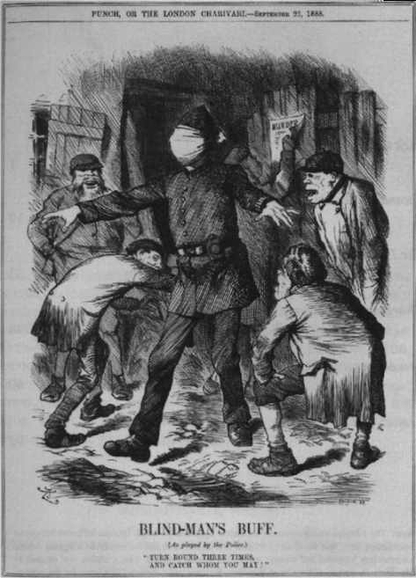

Punch, September 2nd, 1888
(The caption reads “turn round three times and catch who you may”)

Source G

Dear Boss,
I keep on hearing the police have caught me but they won’t fix me just yet. I have laughed when they look so clever and talk about being on the right track. That joke about Leather apron gave me real fits…The next job I do I shall clip the ladys ears off and send to the police officers just for the jolly…My knifes so nice and sharp I want to get to work right away if I get a chance. Good luck.
Yours truly
Jack the Ripper

Letter Dated 25th September and sent to the offices of the Central News Agency, 27th September
Source H
“Whitechapel is loud in its indignation over the efficiency of the detectives and is asking several questions to which there does not seem to be any satisfactory answer. Among other things the people wish to know why the police do not arrest “Leather Apron”. “Leather Apron” by himself is quite an unpleasant character…he is a more ghoulish and devilish brute than can be found in all the pages of shocking fiction…His name nobody knows, but all are united in the belief that he is Jew or of Jewish parentage his face being of a marked Hebrew type…”

The Star Newspaper, 5th September 1888
Source I

“None of these courts had roads. In some, the houses were three storeys high and hardly six feet apart, the sanitary accommodation being pits in the cellars; in other courts the houses were lower, wooden and dilapidated, a stand pipe at the end providing the only water. Each chamber was the home of a family who sometimes owned their indescribable furniture...In many instances broken windows had been repaired with paper and rags, the banisters had been used for firewood, and the paper hung from the walls which were the residence of countless vermin.”

Description of East End housing by social reformer Henrietta Barnett, from East End 1888, W Fishman

