Jack the Ripper Controlled Assessment
Background Information and Sources and Questions



Who was Jack the Ripper?
A study in Victorian crime and society

This is a photograph of Buck’s Row, Whitechapel. It was taken in the 1960’s but little had changed since 1888:

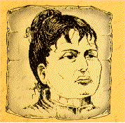 | 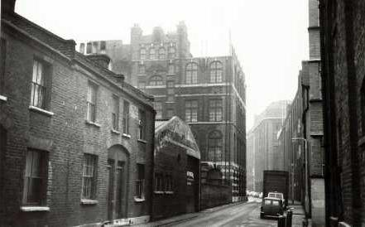

This spot is important as it is where our mystery starts. The photo shows where PC John Neil made a shocking discovery. In the early hours of Friday, 31st of August he found the body of a young woman Mary Anne Nichols. This woman would be remembered as the first victim of a notorious serial killer who stalked the streets of London in 1888. This man came to be known as Jack the Ripper.

The Hunting Ground

In order to understand the type of man that Jack the Ripper was it is important to know information about his victims and the places he found them. You first task is to produce a background report on the area that Jack stalked, the area from which he abducted vulnerable young women. This area was called Whitechapel.

London in 1888 was a divided city. Like today the West End was the wealthiest area and the East End was much poorer. Jack the Ripper operated in the East End. Can you think why?

During the Industrial Revolution lots of people moved from the countryside to the towns to look for work. This meant that towns grew very quickly and facilities in towns such as housing and rubbish collection could not keep up with the rapidly growing population. This meant that towns became crowded, dirty and polluted places.

In some areas, such as Whitechapel, back to back housing was built. This type of housing aimed to get the largest amount of people in the smallest space.
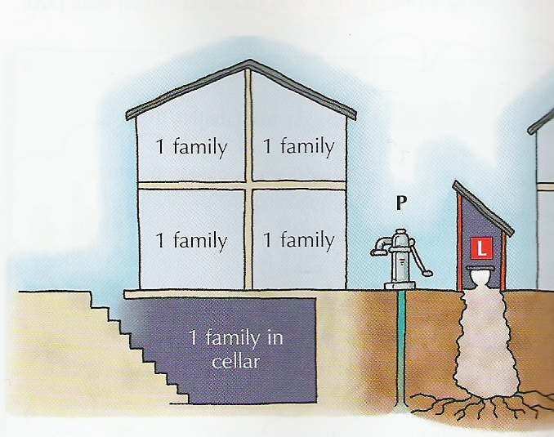
Here is an example of back to back housing. There was one family in each room and one in the cellar. They shared a water pump and toilet with other houses. Sometimes there were open sewers in the streets. What do you think it was like to live in this type of house?
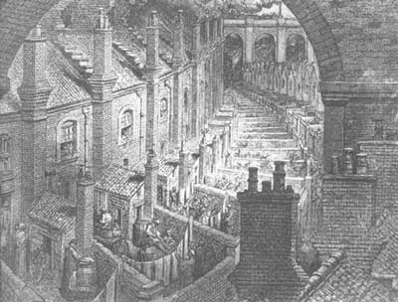
Look at theses pictures of back to back housing. Why do you think Jack the Ripper chose to hunt here?
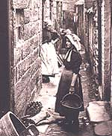

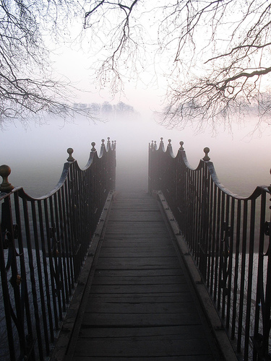
Another problem on the narrow and twisted streets of Whitechapel was the fog. The Industrial Revolution meant that there was an increase in factories as well as people. This meant that more fossil fuel was used in cities and this resulted in more pollution. One of the products of this was a thick fog often referred to as a ‘pea souper’. This fog was made up of a foul mixture of soot smoke and fog. This meant that many parts of Whitechapel were often in darkness even during the day. People were sometimes unable to see their hands in front of their faces. How do you think that this helped Jack the Ripper?

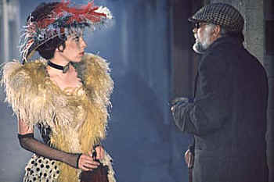
In areas such as Whitechapel there were lots of poor people who had come to London in search of a better life but ended up living in poverty. Women in particular found it hard as in this time there were few jobs that they were allowed to do. As there was no child benefit or unemployment benefit this mean that lots of the women in Whitechapel were desperate and resorted to prostitution to survive. To cope with the poverty and terrible lifestyles many women resorted to alcohol. Cheap gin was widely available and led to many women becoming helpless alcoholics. How would these factors help Jack the Ripper?

The Victims

Polly Nichols Back ground information

The first victim of Jack the Ripper as a lady called Mary Anne Nichols or ‘Polly’ as she was known to her friends. She was born on the 26th August 1845 in Dean Street, Whitechapel. Her father, Edward Walker, was a locksmith and when Polly married William Nichols in January 1864, the couple moved in with him. Why do you think they moved in with Polly’s dad?

William Nichols was a printer’s machinist. He and Polly lived with her father for ten years and then moved into their own house at Peabody Buildings, Stamford Street. They had five children between 1866 and 1879. Polly and William separated in 1880.

Polly lived in Lambeth workhouse from 6th September 1880 until 31st May 1881. William paid Polly an allowance of 5 shillings a week until he found out she had started living with another man. Polly’s remaining years were spent in workhouses and doss houses. Between 24th April 1882 and 24th March 1883 she lived at Lambeth workhouse. There is a gap of about 4 years when Polly lives with her father again, but they quarrelled because Polly was a heavy drinker. She left her father and lived with a blacksmith called Thomas Drew.

On 25th October 1887 she stayed at St Giles workhouse. Then, from 26th October to 2nd December 1887 she stayed at the Strand Workhouse. One 19th December she returned to Lambeth workhouse but was thrown out ten days later. On 4th 1888 she was admitted the Mitcham workhouse, but transferred back to Lambeth on 4th April 1888. She remained there until the 12th May.

 | She left the workhouse and found herself a job as a domestic servant. She wrote a letter to her father telling him how she was pulling herself together. However, on 12th July 1888 she stole clothing worth £3 10s from her employer and left her job. She then shared lodgings with Ellen Holland in Thrawl Street. She left there a week before her death. On the night of 30th August she did not have
enough money to return to Thrawl Street. She told the lodging house keeper “I’ll soon get my doss money. See what a jolly bonnet I have.” What do you think she meant?
In the early hours of Friday 31st August Polly found herself in Buck’s Row, Whitechapel where she met her killer.

Polly spent a lot of time living in different workhouses. In order to understand her life it is important to learn about these institutions. Work houses were meant to be placed where poor people could go if they had no where to stay so why would Polly prefer to get money from prostitution to pay for lodgings rather than stay there?

A workhouse was a grim, large building in each town where the poor were kept like prisoners. They were forced to work, families were separated, uniforms were worn and rules were harsh. This is because at the time rich people believed that people were poor because they were lazy and that they should be punished so they worked harder and became richer.

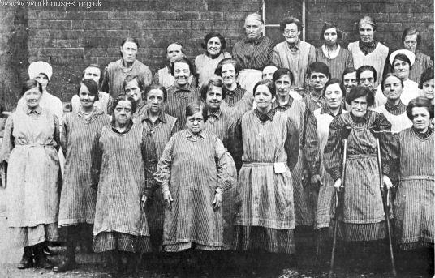 | The poor entered a workhouse only after a humiliating interview, called the workhouse test, to prove that they deserved to be helped. Families were then split up. People had to dress in workhouse clothes and have their hair cut short to reduce the problem of lice. In some workhouses unmarried mothers were forced to wear yellow to show them up!

Inside the workhouses the windows were too high for people to easily look out and the window ledges were sloped to prevent poor people from putting objects on them. There were no lockers as personal possessions were not allowed. | 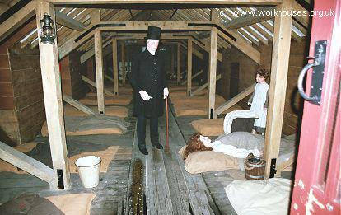

The routine of the workhouse was as boring as possible. Paupers got up early, assembled for a register and prayers and ate in silence. They then started work. Men did hated jobs like crushing bones for glue and fertiliser, or picking oakum (untwisting lengths of rope so that the fibres could be reused). Women scrubbed, cleaned, did the washing and prepared the food. Children had at least 3 hours schooling in reading, writing and the Bible. The diet was healthy but without much variety. Paupers often went hungry.

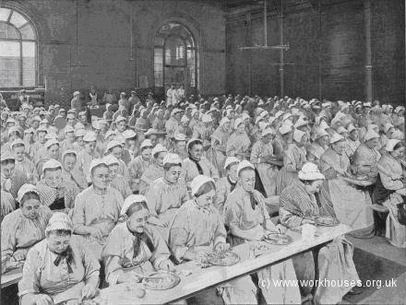
  Sunday | Bread & Cheese | Meat | Broth
  Monday | Broth | Pease-Porridge | Bread and Cheese
  Tuesday | Bread & Cheese | Hasty-Pudding | Bread and Cheese
  Wednesday | Bread & Cheese | Meat | Broth
  Thursday | Broth | Frumety | Bread and Cheese
  Friday | Bread & Cheese | Ox-Head | Broth
  Saturday | Broth | Hasty-Pudding | Bread and Cheese
Punishments in the workhouses were often harsh. They included missing meals, solitary confinement and beatings. Here are examples of some punishments given out at Keighly workhouse.

Name | Offence | Date | Punishment
Elliott, Benjamin | Neglect of work | 31 May 1842 | Dinner withheld, and but bread for supper.
Rowe, Sarah | Noisy and swearing | 19 June 1842 | Lock'd up for 24 hours on bread and water.
Mintern, George | Fighting in school | 26 July 1842 | No cheese for one week.
Park, James | Deserted, got over wall | 4 Sep 1843 | To be whipped.
Hallett, Isaac | Breaking window | 25 April 1844 | Sent to prison for 2 months hard labour.
Staple, John | Refusing to work | 7 Jany. 1856 | Committed to prison for 28 days.
Soaper, Elizabeth | Making use of bad language in bedroom.  Trying to excite other inmates to insubordination. Refusing to work. | 17 Jany. 1863 | Taken before the Magistrate & committed to prison for 14 days hard labour.

The authorities thought that workhouses were a real success as the cost of looking after the poor went down by approximately 50%. Do you think that workhouses sound like a success?  In 1842 there were large numbers of unemployed people in Stockport and Preston. They rioted rather than go into the workhouse. Why do you think that this was? | 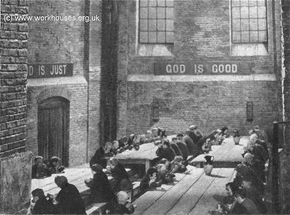

The other victims

Polly was only the first of 5 victims. In order to make a character profile of Jack the Ripper it is important to find any similarities in his victims, Below is information about the other four victims of Jack the Ripper.
Annie Chapman was born in 1841. At the time of death she was suffering from Tuberculosis and Syphilis. She was a heavy drinker but not an alcoholic. In 1869 she married a coachman, John Chapman and had three children. Emily was born in 1870, Annie was born 1873 and John was born in 1881. John was a cripple and was sent to a home. Emily died of meningitis aged twelve and Annie left home in 1877 to work with a travelling circus in France. In 1888 Annie separated from her husband and became a prostitute. By June 1888 she was living at a lodging house for 300 people. In the early hours of Sep 8th she left the house to earn some money. She was last sighted with a “customer” at 5.30am. She was found dead early that morning.

Elizabeth Stride – 29th September 1888
Elizabeth was born in Sweden in 1843. By 1860 she was working as a servant. The police registered her as a prostitute in 1865; she was later treated for venereal disease. In 1866 she moved to the Swedish parish in London and married John Thomas Stride, a carpenter. After the marriage John and Liz kept a coffee shop but later she separated from her husband. By 1882 she had moved into a workhouse. In 1885 she lived with Michael Kidney, a waterside labourer, who said that she was frequently absent when she was drinking and he even tried, unsuccessfully, to padlock her in. On Sep 30th she left a pub in the early hours with an unidentified man, and was found dead later on that morning.

Catherine “Kate” Eddowes – 29th September 1888
Kate was born in Wolverhampton in 1842 but moved to London with her father. Her mother died c.1860 so she returned to Wolverhampton and was educated by her aunt. Between 1861-1863 she left home with Thomas Conway, an old soldier. The couple sold cheap books in Birmingham. As a couple they had three children. Annie was born 1865, George was born around 1868 and another son was born around 1875. Kate developed a drinking problem around 1881 and returned to London where she moved in with John Kelly. On September 28th 1888 they both rented a cheap bed for a night at different doss houses. On Sep 29th Kelly pawned some boots so that he and Kate could have breakfast together. At 8pm she was arrested for being drunk and disorderly (imitating a fire engine) and put in the cells. On Sep 30th she was released in the early hours of the morning. At 1.45am her body was found 10 minutes away from the station.
Mary Jane Kelly – 9th November 1888
Mary Jane Kelly was born in Limerick in 1863 and. c.1870 her family moved to Wales. In 1879 she married a collier named Davies but he was killed in 1882 so Kelly moved to Cardiff and worked as a prostitute. She arrived in London in 1884 where she worked in a high class brothel in the West End and just one year later she developed a drink problem so moved to Mrs. Carthy’s brothel in the East End. Mary Jane returned to the streets in 1888. In September she was fined 2/6 by the Thames Magistrate Court for being drunk and disorderly. By October Mary was letting prostitutes sleep in her room. On November 8th 1888 (evening) Kelly was last seen singing in the street, completely drunk. But on November 9th Kelly’s landlord, demanding her rent, broke into her room and found her terribly mutilated body on the bed.

The Police

. The police force in London was a relatively new organisation. It was founded in 1829 by Sir Robert Peel. It was known as the Metropolitan Police Force and at first dealt with the city with the biggest crime problem, London. Three thousand men were recruited. |  | 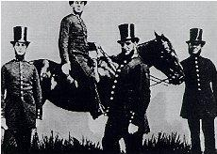
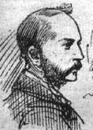 | They had to be less than 35, healthy and be able to read and write. They were given a new blue uniform, boots, a wooden truncheon, a rattle, handcuffs, a brown coat and a top hat lined with iron. They received 5p a day and were expected to walk their ‘beat’ 7 days a week.  The main investigation was headed by Sir Charles Warren of Scotland Yard and Sir Robert Anderson of the CID. They did not get on well and did not co operate.

Here is list of methods that have been suggested for use in your investigation.

Jack the Ripper the Sources

Source A: Charles Booth’s Map of London Poverty, 1889

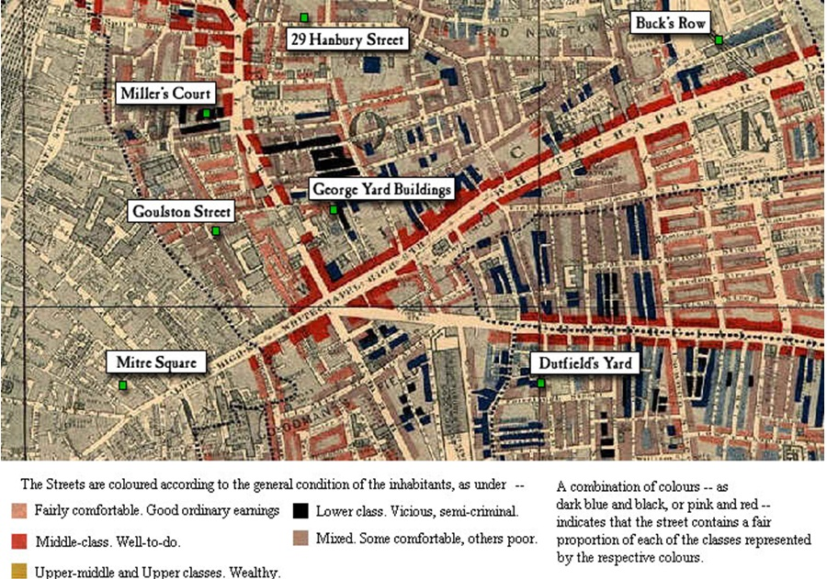

GCSE controlled assessment: Whitechapel at the time of the Ripper murders

Source B

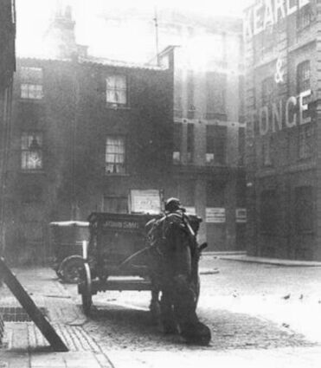
Photograph of Mitre Square, end of nineteenth century

Source C

“Turn down this side street out of the main Whitechapel Road. It may be well to tuck out of view any bit of jewellery that may be glittering about… The street is oppressively dark, though at present the gloom is relieved somewhat by feebly lighted shopfronts. Men are lounging at the doors of the shops, smoking evil-smelling pipes. Now round the corner into another still gloomier passage, for there are no shops here to speak of. This is the notorious Wentworth Street. The police used to make a point of going through this only in couples, and possibly may do so still when they go there at all. It is getting on into the night, but gutters, and doorways, and passages, and staircases appear to be teeming with children. Listen for a moment at this next house. There is a scuffle going on upon the staircase - all in the densest darkness - and before you have passed a dozen yards there is a rush down-stairs and an outsurging into the street with fighting and screaming… it makes you shudder as you look at those curly-headed sharp-witted children who leave their play to gather around the mêlée. God help the little mortals! How can they become anything but savages, “pests of society,” the “dangerous classes,” and so on? How black and unutterably gloomy all the houses look!”

An Autumn Evening in Whitechapel
3 November 1888, Littell's Living Age, (a magazine)

Source D
Sir,
In reply to your letter I enclose a report of the circumstances of the Mitre Square Murder and I now give an account regarding the erasing of the writing on the wall in Goulston Street …
On the 30th September I arrived at Leman Street Station shortly before 5 A.M. and ascertained from the Superintendant Arnold all that was known there relative to the two murders. The most pressing question at that moment was some writing on the wall in Goulston Street evidently written with the intention of inflaming the public mind against the Jews, and which Mr. Arnold, with a view to prevent serious disorder, proposed to obliterate, and had sent down an Inspector with a sponge for that purpose, telling him to await his arrival.
I considered it desirable that I should decide the matter myself, as it was one involving so great a responsibility whether any action was taken or not. I accordingly went down to Goulston Street at once … it was just getting light, the public would be in the streets in a few minutes, in a neighborhood very much crowded on Sunday mornings by.
The writing was on the jamb of the open archway or doorway visible in the street and could not be covered up without danger of the covering being torn off at once.
A discussion took place whether the writing could be left covered up or whether any portion of it could be left for an hour until it could be photographed; but after taking into consideration the excited state of the population in London generally at the time, the strong feeling which had been excited against the Jews, and the fact that in a short time there would be a large concourse of the people in the streets…I considered it desirable to obliterate the writing at once, having taken a copy of which I enclose a duplicate.
I do not hesitate myself to say that if that writing had been left there would have been an onslaught upon the Jews, property would have been wrecked, and lives would probably have been lost; and I was much gratified with the prompitude with which Superintendent Arnold was prepared to act in the matter if I had not been there.
I am, Sir,
Your most obediant Servant,
(signed) C. Warren
Charles Warren's Report to the Home Secretary 6 November 1888
Source E

“Crime and prostitution lingered amidst the poverty and squalor, especially in parts of Spitalfields. In these overcrowded labyrinthine slums, where policemen were traditionally greeted with suspicion, if not outright hostility, the Whitechapel killer had chosen a perfect hunting ground.”

Philip Sugden,
The Complete History of Jack the Ripper, 2002
Source F

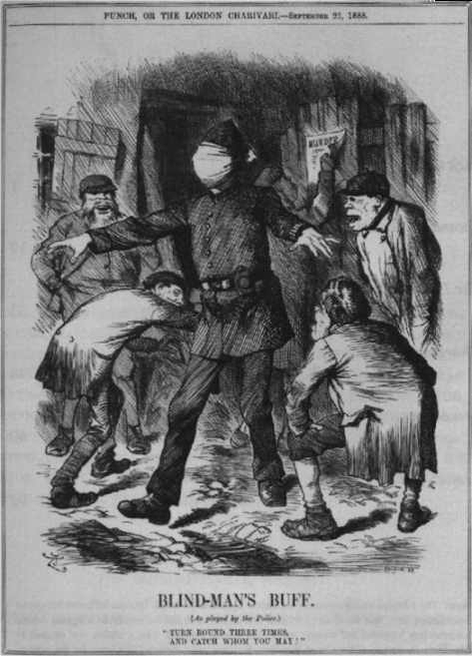

Punch, September 2nd, 1888
(The caption reads “turn round three times and catch who you may”)

Source G

Dear Boss,
I keep on hearing the police have caught me but they won’t fix me just yet. I have laughed when they look so clever and talk about being on the right track. That joke about Leather apron gave me real fits…The next job I do I shall clip the ladys ears off and send to the police officers just for the jolly…My knifes so nice and sharp I want to get to work right away if I get a chance. Good luck.
Yours truly
Jack the Ripper

Letter Dated 25th September and sent to the offices of the Central News Agency, 27th September
Source H
“Whitechapel is loud in its indignation over the efficiency of the detectives and is asking several questions to which there does not seem to be any satisfactory answer. Among other things the people wish to know why the police do not arrest “Leather Apron”. “Leather Apron” by himself is quite an unpleasant character…he is a more ghoulish and devilish brute than can be found in all the pages of shocking fiction…His name nobody knows, but all are united in the belief that he is Jew or of Jewish parentage his face being of a marked Hebrew type…”

The Star Newspaper, 5th September 1888

Source I

“None of these courts had roads. In some, the houses were three storeys high and hardly six feet apart, the sanitary accommodation being pits in the cellars; in other courts the houses were lower, wooden and dilapidated, a stand pipe at the end providing the only water. Each chamber was the home of a family who sometimes owned their indescribable furniture...In many instances broken windows had been repaired with paper and rags, the banisters had been used for firewood, and the paper hung from the walls which were the residence of countless vermin.”

Description of East End housing by social reformer Henrietta Barnett, from East End 1888, W Fishman

Controlled Assessment Questions

Question 1
In what ways did the development of Whitechapel in the period of the 19th century make it an ideal hunting ground for a mass murderer in 1888? (20 marks) 1,000words

Question 2
How valid is the interpretation of Whitechapel in 1888 given in the ABC 1988 Commemorative film ‘Jack the Ripper’? Test the validity of the interpretation and support your answer using the site, the sources and information you have been given and your own research (20 marks) 1,000 words

