The Top Six Social Science Structures
- Rally Robin
Purpose – starters connect the learning, review, mastery, apply material to new challenge
Description
Students take turns to answer an open ended question
Suggestions – use the WALT Q, review last week’s learning, make a list of factors

- Stand and Share
Purpose – sharing information, learning from each other, accountability – always good linked a rally robin
Description
Students Stand with their lists and draw a line under their own lists. Teacher uses the random name generator or random table number generator to ask students to contribute a response when called. Students tick off their own answers as they are shared and add any new ones to their list below the line. They sit down when everything on their list is ticked – game over when everyone sitting down

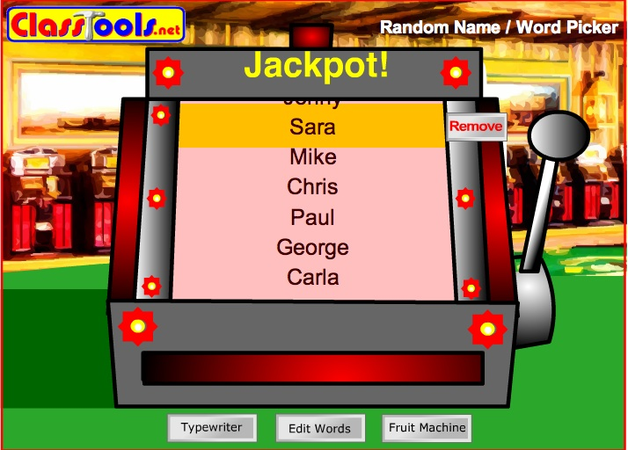

- Mix Pair Share
Purpose: mini plenaries, oracy, review, mastery, AFL
Description
Students Stand Up Hand Up Pair Up
Stand back to back. Teacher sets an open ended Q... gives think time. Students face each other. Partner A answers Partner B listens then partner B paraphrases and extends

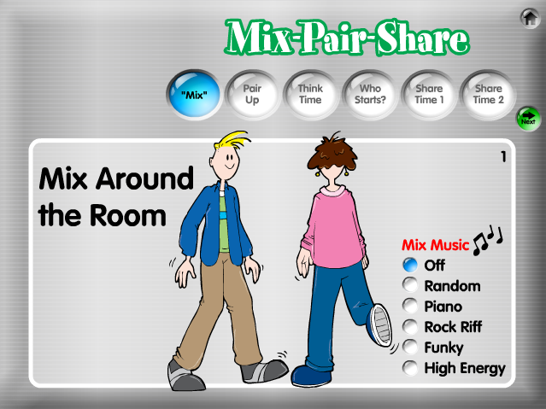

Variations
Write pair Share -same process but students get longer are given an exam style question, write then share and assess each other’s responses perhaps using wilfs or markschemes.

- Quiz Quiz Trade
Purpose – mastery, knowledge building, literacy, oracy
Description – set up – teachers prepares a set of q cards for the class – each student given a card
Students Stand Up Hand Up Pair Up
Partner A quizzes partner B – coaching – switch roles – partners trade cards and move on to someone else and repeat process
Suggestion – as part of our literacy push use with Key words and new words

- All Write Consensus
Purpose - for sharing information, learning process/procedure, AFL, mastery, oracy, literacy
Description – students sit in table groups
The purposes of this structure is to find a ‘consensus’ answer to each question – something you can all agree to or at least all live with.You will get 5 minutes to Round Robin your views to establish a consensus answer, then a further 7-8 minutes to write you answers on the sheet individually. This process will be repeated until the task sheet is complete. Then swap and mark using mark scheme. Feedback a grade a level a www and an ebi
Example Question A level Sociology
While in the past the main political parties had distinctive ideologies, this is no longer the case today.”
To what extent do sociological arguments and evidence support this view? (40 marks)

Level 1 – can identify main political parties and some of their ideas – does not address the question (0-8) U
Level 2 – writes coherently about socialism, conservatism and liberalism and describes their importance in the past (9-15) E-D
Level 3 – as above but also starts to assess whether ideological distinctions have increased or decreased in recent years ... assessment not sustains. Uses theory and evidence but may be imbalanced (16- 26) C-B
Level 4 – as above but offers a sustained and supported judgement drawing on theoretical understanding and up to date knowledge of recent changes and party policy (27-40) A-A*

- Simultaneous Round Table/ Round Table
Purpose – plenaries, mini plenaries, review, generate new ideas, creativity, speculation
Description – in a Round Table one question on one piece of paper is past around the table and pupils record their responses. In a simultaneous round table 4 sheets with 4 different but related qs rotate. Activity is timed.

