Reichstag Fire Discussion points

Study the Source from a Modern anti Iraq War web site. Discuss the questions below in your group and be prepared to feedback in 15 minutes. After the feedback save this file in your area and add your own considered written answers. Then print your work.

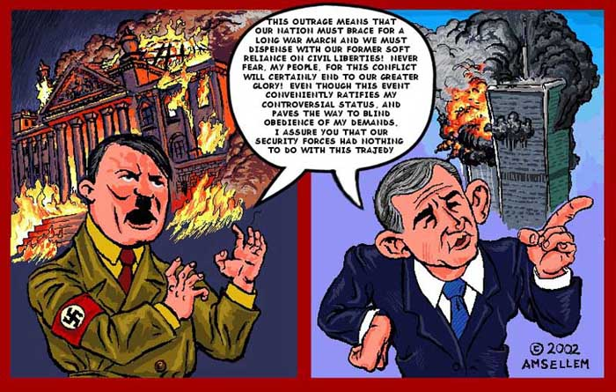

Discussion Points

What do you think are the motive of the person who drew this cartoon?

Are there any similarities between the Reichstag Fire and 9/11?

How valid is the interpretation of the Reichstag fire given in the cartoon?

How valid is the interpretation of 9/11 given in the cartoon?

Written Answers

