The Hitler Youth
1926-1945

Background
The Nazis believed that if Hitler and the Party were going to gain power in Germany, the support of young people would be vital to the consolidation of that power. The youth, if controlled and inspired, would bring enthusiasm and energy, dedication and loyalty to the Nazi Party. The young people of Germany would also be essential if Germany was to improve the economy. Young people would also be important if Germany decided to go to war with other countries within Europe, and around the World to achieve the Nazi goal of a ‘Thousand Year Reich’. The children were, after all, the future of Germany.

The Nazis needed to indoctrinate young Germans. To gain more control over what children saw and heard, they founded the Hitler Youth (HJ) in 1926. This organisation offered excitement to many young people: hikes, camps and comradeship. Members were provided with uniforms and were made to feel important. Boys were given instruction in skills such as orienteering and military drill, while girls were taught how to care for young children and the home.

By early 1932, one year before Hitler became Chancellor of Germany there were 108,000 members of the Hitler Youth. By 1939, just before the outbreak of World War Two there were 7.3 million. Why was there such an increase in membership between 1933 and 1939?

Hitler placed great emphasis upon the education of young people. When he came to power, the Nazis changed the school curriculum to emphasise Nazi ideas and promote Nazi values. All youth groups other than the Hitler Youth were banned. In 1936 The Hitler Youth Law was passed. This announced that ‘all German young people, apart from being educated at home and at school, will be educated in the Hitler Youth physically, intellectually, and morally in the spirit of National Socialism to serve the nation and the community.’ Membership of the Hitler Youth became compulsory in 1939.
For many young people and their families who were suffering from the effects of Depression during the 1920’s, and especially after The Wall Street Crash of 1929, the Hitler Youth must have offered an opportunity for youths to enjoy activities in the fresh air of the countryside, away from the hardships experienced at home. The chance to go away on adventure weekends, hiking and camping in the outdoors must have been appealing. Healthy food was often cooked in the open and everyone joined together in activities and team sports that had been organised.

Both boys and girls were encouraged to take part in activities that would increase their fitness levels and general physique. Both were taught Party Beliefs and to sing folk and Nazi Party songs. This was part of the indoctrination process. There was however a militaristic approach to boys activities: war games, rifle practice, hiking and orienteering. The girls were encouraged to engage in domestic tasks, learning the skills necessary to bring up a healthy and happy family.

Key Dates
1926 – The Hitler Youth movement was formed

1931 – Baldur von Schirach was appointed Reich Youth Leader
1936 - The Hitler Youth Law

1936 – The Nuremberg Rally was attended by 100,000 members of the HJ and BDM

1939 – It became compulsory to join the Hitler Youth

Which of the following activities would have been more likely to have been undertaken on a regular basis by:
The Hitler Youth (HJ)?
The League of German Maidens (BDM)?

Note: Some activities may have been undertaken by both.
Boys - HJ
Girls - BDM
Both
Key:
Preparation for Motherhood

Domestic Work and Health Care

Hiking and Rifle Practice
Singing Practice – Folk and Nazi Party Songs

Sporting Activities –
e.g. Gymnastics, Javelin Throwing

Camping, Orienteering and Military Drill

Leadership Qualities
(including Courage and Public Speaking)

Tasks involving high levels of
Discipline and Obedience

War Games
e.g. Hunting the Enemy

Needlework and Cookery
Alternative Youth Organisations

Not all youths within Nazi Germany wanted to belong to the Hitler Youth. Whereas many youths enjoyed the outdoor activities such as hiking and camping, others did not. Many youths found the forced comradeship, the harsh discipline, regimentation and spending time away from home, laborious and distressing. Some girls found it hard to accept that they were expected to devote their time within and outside of school to learning about how to care for children and the home. Many were not prepared to plan out their futures solely around bringing up families and completing domestic chores.

The Hitler Youth and League of German Maidens advocated career paths that not all youths wanted to follow. The organisation also discouraged many activities enjoyed by the young – for example listening to modern music such as Jazz, following fashion and experimenting with hair styles. The influence of new fashions and music styles from abroad (especially the USA) caused many youths to question the harsh dress code and ‘purist’ ideas advocated by the HJ and BDM.

Many youths rebelled by breaking Hitler Youth rules, but few openly opposed the authorities by joining alternative youth groups. Some of these gangs drank, smoked, beat up Hitler Youth members and even collected propaganda leaflets dropped by the Allies and put them through people’s letterboxes. One group, The Edelweiss Pirates also helped the odd Allied airman to escape. It is not surprising that these gangs were treated with contempt by the authorities and discovery of membership could result in harsh punishment. Some gang members were beaten and hung by the Gestapo in an attempt to ‘discourage’ other youths from breaking the law.

Examples of alternative youth organisations:
The Navajos Gang

The Edelweiss Pirates

The Kittelbach Pirates
So what have I learnt about the H.J.?
(Some information has already been added for you)

You experienced outdoor activities such as hiking and camping

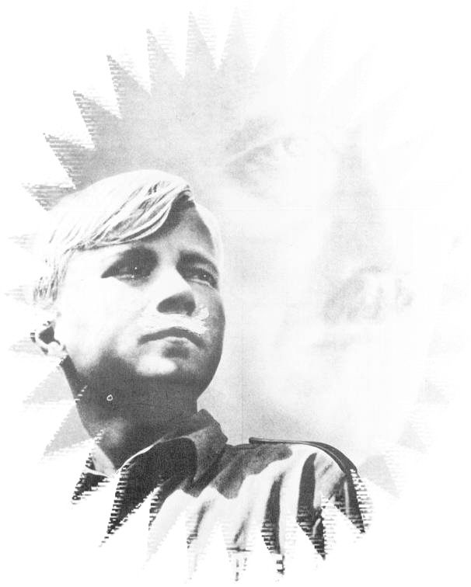

By 1939 there were 7.3 million members of The Hitler Youth

So what have I learnt about Alternative Youth Groups?
(Some information has already been added for you)

Ernst Rohm shared Hitler’s vision of a racially
pure society
Alternative youth groups sprang up across Germany - e.g. The Edelweiss Pirates,
The Navajos Gang, The Kittelbach Pirates…

