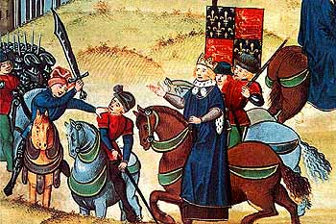
The Peasants’ Revolt
Assessment Part 1: Listening
- Where did the revolt begin?

- What had made the peasants so angry in 1381?

- Who was John Ball?

- What was the connection between the revolt and the Black Death?

- How many rebels were there?

- Who was the king and how old was he?

- How brave was the king?

- What did the peasants do when they entered London?

- What happened at Smithfield?

- What did the king say to the crowd?

a. How far did the king keep his promises?

b. Why do we remember the Peasants’ Revolt today
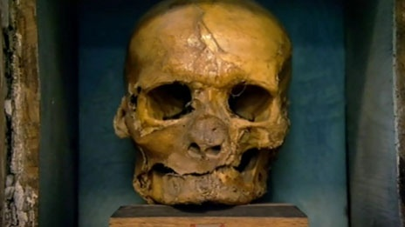

The remains of Simon Sudbury

