AllWrite Consensus

Sit with your Study Buddy opposite 2 others at a table.
The purposes of this structure is to find a ‘consensus’ answer to each question – something you can all agree to or at least all live with.
You will get 10 minutes to Round Robin your views to establish a consensus answer, then a further 15 minutes to write you answers on the sheet. This process will be repeated until the task sheet is complete. Then swap and mark with revision twin.
Source
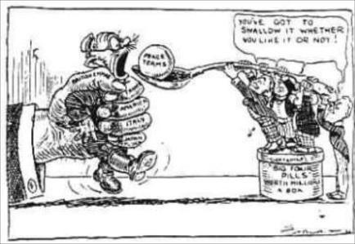

Question 1
Weimar

1 (a) Why was the Weimar Constitution important? (4 marks)
1 (b) Using the source and your own knowledge explain why there were revolts against the Weimar government between 1919-23 (8 marks)

Mark scheme

- Part a
Level 1 – shows a simple understanding of what the Weimar constitution was in a couple of limited sentences (1-2)
Level 2 – Explains fully what the Weimar Constitution was listing strengths and weaknesses and explains why it was important in making life difficult for the Weimar government )3-4)

1 part b

Level 1 – describes some features of the Weimar government 1919-23 accurately but doesn’t answer the questions set (1-2)
Level 2 – Gives one reason/cause and links it to one of the revolts (3-%)
Level 3 – Explains more than one cause and links to the revolts. Uses source and knowledge. Causes could include – Versailles Treaty, stab in the back myth, reparations, Invasion of the Ruhr

